We will be using R in this class. Here’s is how to get the desktop version.

1. **First**, you will need **R**. Here is the link for: <https://cran.rstudio.com/>. Make sure you download the correct version for your operating system (Windows vs. Mac). There is all the info on these pages. As the software is FREE these are NOT the most organized pages. So make sure you read/find the correct links (I presume most of you will install R for the FIRST TIME so use the link that says so).
2. **Second**, you need **R Studio**. This is a very nice user interface for R. You can get a FREE version of R Studio here: <https://www.rstudio.com/products/rstudio/download/>.

After you have successfully installed **R and R Studio** open the software by opening **R Studio**.

In R Studio, you can customize the screen. To set up your screen to look like the screen I will be using click on the field with the four boxes (in the “circle” below) and check “Show All Panes” and “Console on Right”.

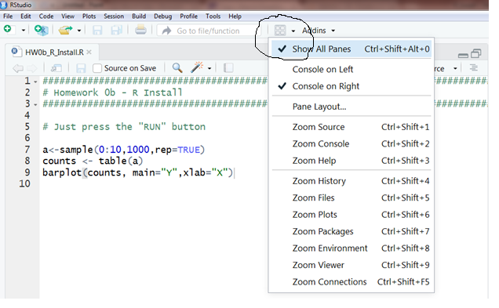

Our screen should look like this:

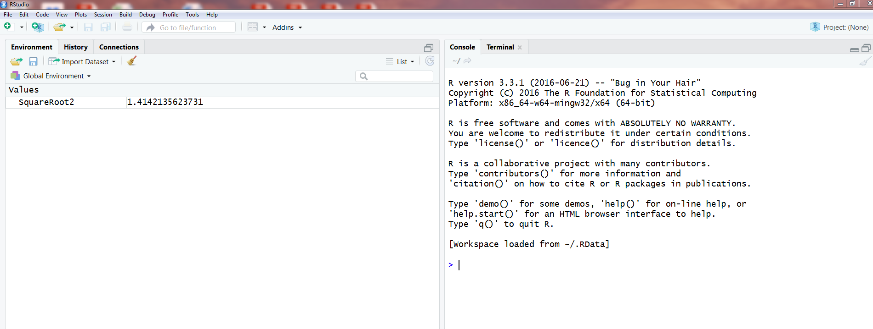

If your screen looks like this:

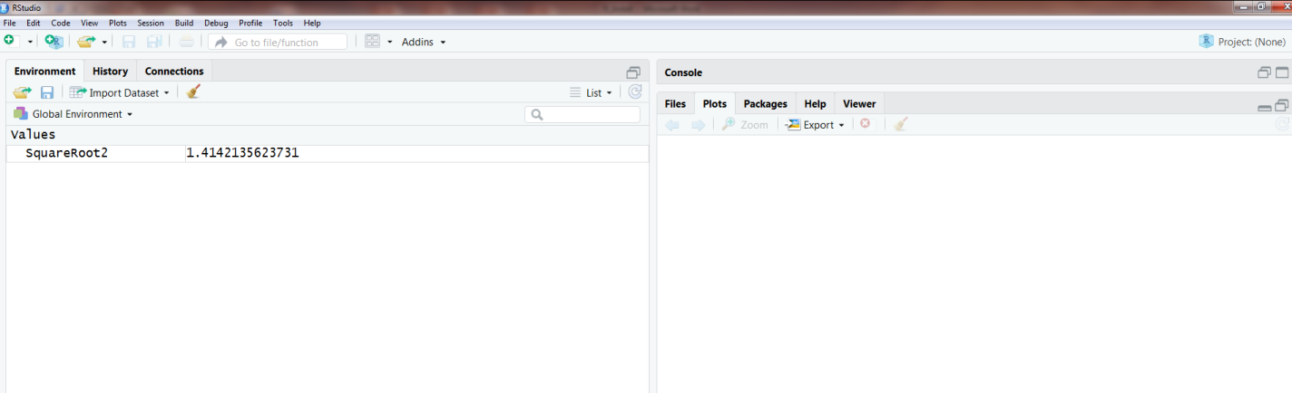

You need to enlarge the “Console” by clicking on here:

